Introduction
Polymorphism is one of the core concepts of Object-Oriented Programming (OOP). It allows methods to do different things based on the object it is acting upon, even though they share the same name. Polymorphism provides a way to perform a single action in different forms. In Java, polymorphism can be achieved through method overloading and method overriding.

Table of Contents
- What is Polymorphism?
- Types of Polymorphism
- Method Overloading
- Method Overriding
- Real-World Examples of Polymorphism
- Example: Polymorphism with Method Overloading
- Example: Polymorphism with Method Overriding
- Example: Payment Processing Example
- Conclusion

1. What is Polymorphism?
Polymorphism means "many shapes" or "many forms." In Java, it refers to the ability of a single method or class to take on multiple forms. This is achieved through method overloading (compile-time polymorphism) and method overriding (runtime polymorphism).

2. Types of Polymorphism
- Compile-time Polymorphism (Method Overloading): This type of polymorphism is resolved during compile time. Method overloading allows a class to have more than one method with the same name, provided their parameter lists are different.
- Runtime Polymorphism (Method Overriding): This type of polymorphism is resolved during runtime. Method overriding allows a subclass to provide a specific implementation of a method that is already defined in its superclass.

3. Method Overloading
Method overloading occurs when a class has multiple methods with the same name but different parameter lists (different types or numbers of parameters).

Example:
public class MathUtils {
public int add(int a, int b) {
return a + b;
}

public double add(double a, double b) {
return a + b;
}

public int add(int a, int b, int c) {
return a + b + c;
}
}

4. Method Overriding
Method overriding occurs when a subclass provides a specific implementation of a method that is already defined in its superclass.

Example:
class Animal {
public void makeSound() {
System.out.println("Animal makes a sound");
}
}

class Dog extends Animal {
@Override
public void makeSound() {
System.out.println("Dog barks");
}
}

class Cat extends Animal {
@Override
public void makeSound() {
System.out.println("Cat meows");
}
}

5. Real-World Examples of Polymorphism

Example 1: Different Behaviors of a Person
Suppose you are in a classroom, you behave like a student. When you are in the market, you behave like a customer. When you are at home, you behave like a son or daughter. Here, one person exhibits different behaviors in different contexts.
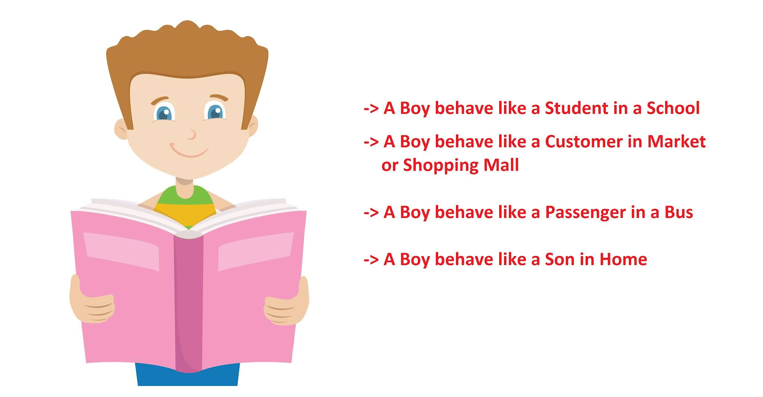

Example 2: Payment Processing System
In a payment processing system, different payment methods such as credit card, debit card, and PayPal have different processing steps.

6. Example: Polymorphism with Method Overloading
Example:
public class Printer {
public void print(String message) {
System.out.println(message);
}

public void print(int number) {
System.out.println(number);
}

public void print(double number) {
System.out.println(number);
}

public static void main(String[] args) {
Printer printer = new Printer();
printer.print("Hello, World!"); // Output: Hello, World!
printer.print(123); // Output: 123
printer.print(3.14); // Output: 3.14
}
}

Explanation:
- Printer: Class with overloaded print methods to handle different types of input.
- Main method: Demonstrates the use of overloaded print methods.

7. Example: Polymorphism with Method Overriding
Example:
class Animal {
public void makeSound() {
System.out.println("Animal makes a sound");
}
}

class Dog extends Animal {
@Override
public void makeSound() {
System.out.println("Dog barks");
}
}

class Cat extends Animal {
@Override
public void makeSound() {
System.out.println("Cat meows");
}
}

public class Main {
public static void main(String[] args) {
Animal myDog = new Dog();
Animal myCat = new Cat();

myDog.makeSound(); // Output: Dog barks
myCat.makeSound(); // Output: Cat meows
}
}

Explanation:
- Animal: Base class with a makeSound method.
- Dog and Cat: Subclasses that override the makeSound method.
- Main method: Demonstrates runtime polymorphism by calling the overridden methods on Dog and Cat objects.

8. Example: Payment Processing Example

Class Diagram
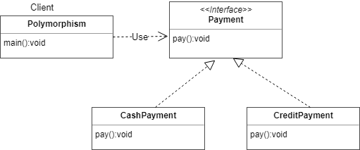
Code Example:
Payment Interface:
interface Payment {
void pay();
}
CashPayment Class:
class CashPayment implements Payment {
@Override
public void pay() {
System.out.println("Payment made using cash.");
}
}
CreditPayment Class:
class CreditPayment implements Payment {
@Override
public void pay() {
System.out.println("Payment made using credit card.");
}
}
Client Class:
public class Polymorphism {
public static void main(String[] args) {
Payment payment;

payment = new CashPayment();
payment.pay(); // Output: Payment made using cash.

payment = new CreditPayment();
payment.pay(); // Output: Payment made using credit card.
}
}

Explanation:
- Payment: Interface defining the pay method.
- CashPayment and CreditPayment: Classes implementing the Payment interface and providing their own implementations of the pay method.
- Polymorphism: Client class demonstrating polymorphism by using the Payment interface to call the pay method on different types of payment objects.

9. Conclusion
Polymorphism in Java is a powerful concept that allows methods to perform different tasks based on the object they are acting upon. It enhances flexibility and maintainability in code by allowing a single method or class to take on multiple forms. Method overloading and method overriding are two ways to achieve polymorphism in Java. Real-world examples like different behaviors of a person in different contexts and various payment processing methods further illustrate the usefulness of polymorphism.

